Software Design Document

This program is a prototype for an RPG game. It has multiple states which show off the basic mechanics of the game. There is a splash screen at startup, which then loads into the main menu. The gameplay is relatively simple but can be expanded on easily. The player can move themselves on screen and pick up items (Health, Strength and Speed upgrades). If the player comes into contact with an enemy they go into a battle state where the monster and player take turns hitting one another till one of them dies. The player is then either taken back to the game or to the main menu depending on the outcome of the battle.

Functions

Monsters
Monster(Player*); - This is the constructor for the Monsters, which player is passed into
virtual ~Monster(); - De-constructor will delete any objects created inside the class when it is called
virtual void Draw(SDL_Window *window) = 0; - draws the monsters to the screen and their labels
virtual bool Update() = 0; - returns a true or false value if there is a collision with the player
float GetXPos(); - returns monsters xpos
float GetYPos(); - returns monsters ypos
float GetXSize(); - returns monsters xsize
float GetYSize(); - returns monsters ysize
int GetID(); - return monsters ID
int GetHealth(); - returns monsters health
int GetStrength(); - returns monsters strength
int GetSpeed(); - returns monsters speed
int GetMoneyDrop(); - returns how much money the monster will drop
int GetDropPercentage(); - returns the drop chance of the monster
void SetXPos(float Xpos); - takes a value and sets the monsters xpos to it
void SetYPos(float Ypos); - takes a value and sets the monsters ypos to it
void SetHealth(int health); - takes a value and set the monsters health to it
void SetStrength(int strength); - takes a value and set the monsters strength to it
void SetSpeed(int speed); - takes a value and set the monsters speed to it
void SetID(int ID); - takes a value and set the monsters ID to it
void SetMoneyDrop(int money); - takes a value and sets how much money the money will drop
void SetDropPercentage(int percentage); - takes a value and sets the drop chance of the monster
void subtractDamage(int); - takes health away from the monsters

Items
Items(Player*); - constructor for the items, passes player in so that items can check for collision
virtual int Update() = 0; - returns an int depending on what item the player has collided with
virtual void Draw(SDL_Window *window) = 0; - draws items to the screen along with their labels
void SetXPos(float Xpos); - takes a value and sets the items xpos to it
void SetYPos(float Ypos); - takes a value and sets the items ypos to it
float GetXPos(); - returns the items xpos
float GetYPos(); - returns the items ypos
float GetXSize(); - returns the items xsize
float GetYSize(); - returns the items ysize
~Items(void); - de-constructor deletes any objects made in the items class when it is called

States
virtual void Draw(SDL_Window*) = 0; - handles the calls to player, monster and item's draw functons
virtual void Update(Game&) = 0; - handles the calls to player, monster and item's update functions
virtual void HandleSDLEvent(SDL_Event const &sdlEvent, Game &) = 0; - handles any keypresses when a state is running
virtual void Enter() = 0; - executes functions when the state is entered
virtual bool GetContinuable() = 0; - used to return a 'continuable' variable
virtual bool GetGameStarted() = 0; - used to return a 'gamestarted' variable
virtual void SetGameStarted() = 0; - used to set a 'gamestarted' variable
virtual void Exit() = 0; - executes functions when the state is exited

Class and State Diagrams

Item Class
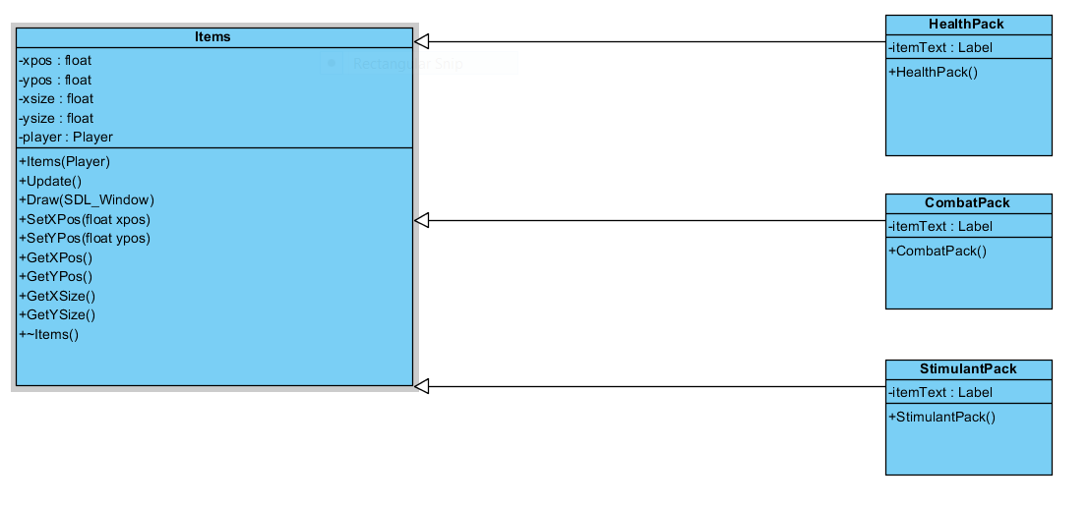
This is the class for the items in the game. 'Items' is an abstract class that HealthPack, CombatPack and StimulantPack all inherit from. These 3 classes have no functions of their own, they just use the functions in the 'Items' class. If you are unable to see the Item Class diagram properly I have uploaded it with the RPG Coursework on bitbucket under the name 'Item Class'.

Monster Class
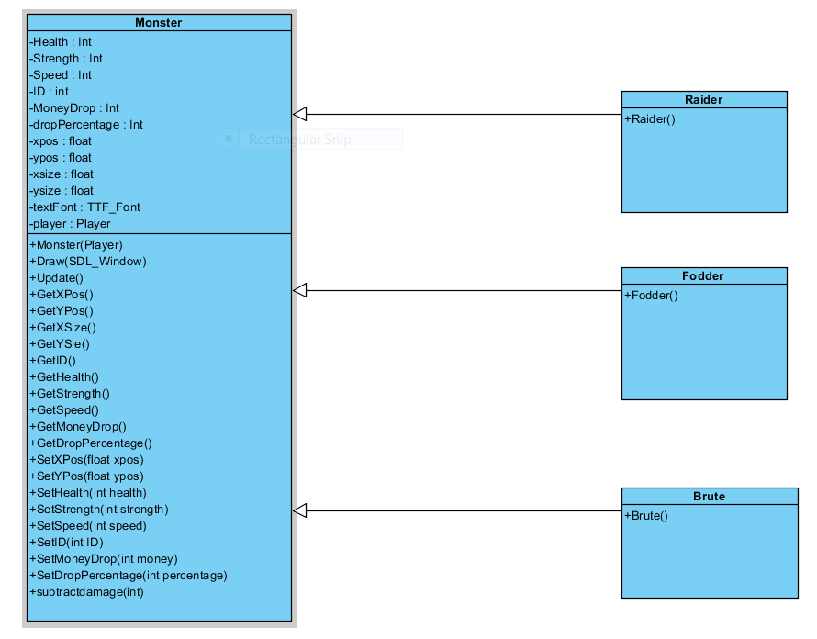

This is the class for the monsters in the game. 'Monsters' is an abstract class that Raider, Brute and Fodder all inherit from. These 3 classes have no functions of their own, they just use the functions and variables in the 'Monster' class. If you are unable to see the Monster Class diagram properly I have uploaded it with the RPG Coursework on bitbucket under the name 'Monster Class'.

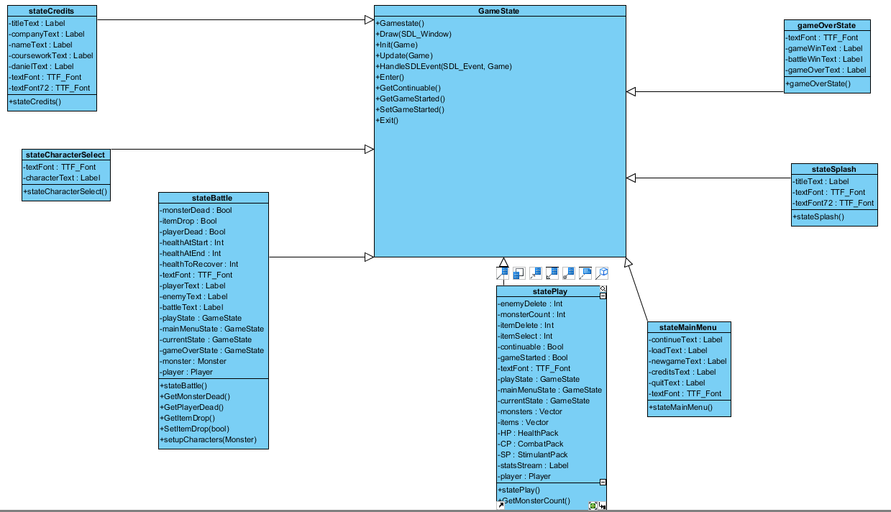
State Class

This is the class for the all the states in the game. 'GameState' is an abstract class that all of the other state classes inherit from. Most of these classes have no functions of their own just use the functions in the 'GameState' class. Some however have their own functions and are used through the method of 'Casting'. If you are unable to see the Item Class diagram properly I have uploaded it with the RPG Coursework on bitbucket under the name 'State Class'.

State Diagram
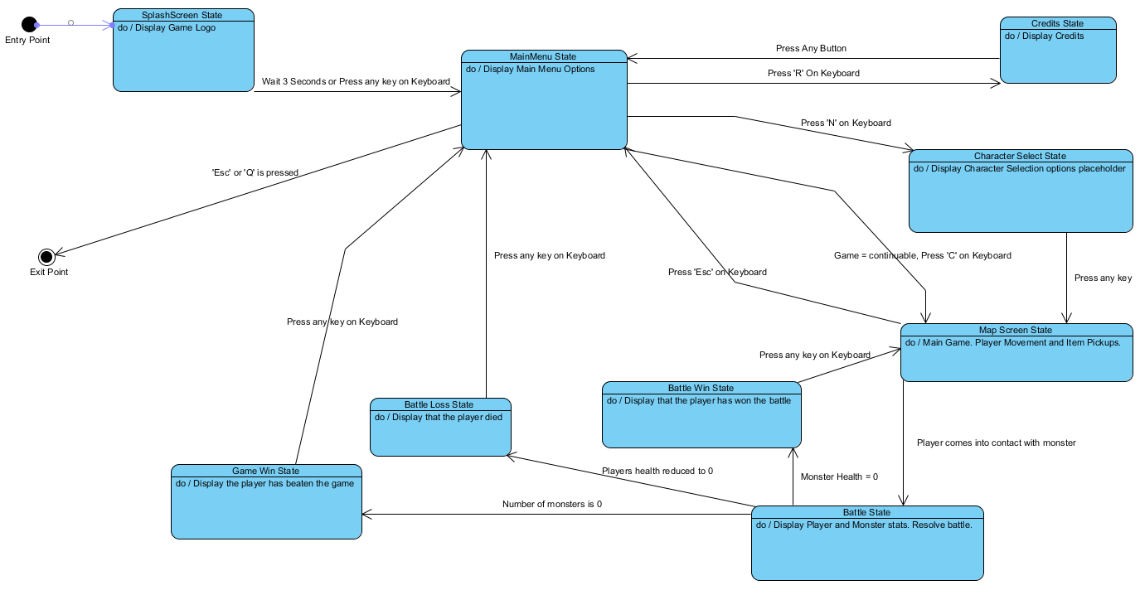
This is the State Diagram which shows how the states all work with each other. It tells you how you transition from one state to another. It also tells you what each of the states do when they are running.

